Software Overview:

**Arduino IDE**

The Arduino Integrated Development Environment (IDE) is an open-source platform that simplifies coding and programming for Arduino boards and compatible microcontrollers. Designed for both beginners and advanced users, it provides an easy-to-use interface for writing, compiling, and uploading code to microcontroller boards. The IDE is built on Java and comes with a text editor for writing code, a message area for status updates, a console for output logs, and a toolbar with buttons for common functions.

Arduino IDE supports a wide variety of libraries and examples, making it easier to develop complex applications involving sensors, actuators, and communication modules. Its simplicity allows hobbyists and professionals to program microcontrollers with ease, whether for prototyping or final applications. Code written in Arduino IDE is based on simplified C++ syntax, making it accessible for those new to programming. Additionally, it supports a serial monitor for debugging and real-time communication with microcontrollers.

Designed to simplify the coding process, it supports C and C++ languages and is compatible with various operating systems like Windows, macOS, and Linux. The open-source nature of the IDE encourages a large community of developers to contribute, making it a versatile and adaptable platform for beginners and professionals alike.

The Arduino IDE will appear as:

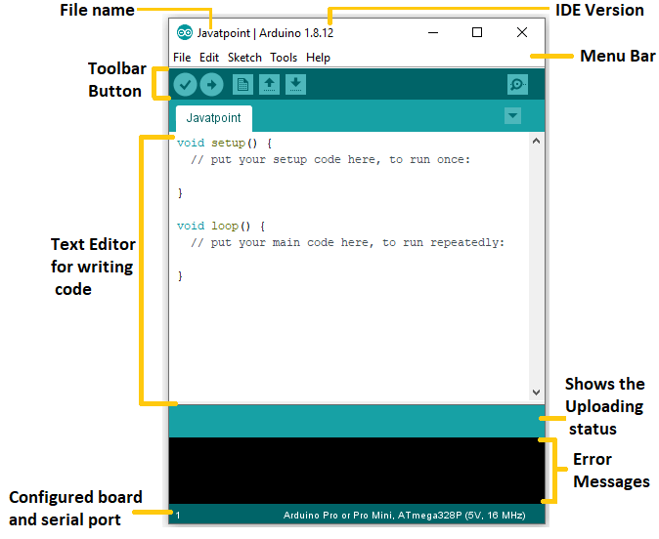

A unique feature of the Arduino IDE is its use of "sketches"—programs written and saved with the .ino extension. These sketches can be easily uploaded to Arduino and Genuino boards through a USB connection. The software's interface is user-friendly, with sections dedicated to code editing, compilation, and debugging, making it an essential tool for microcontroller-based projects.

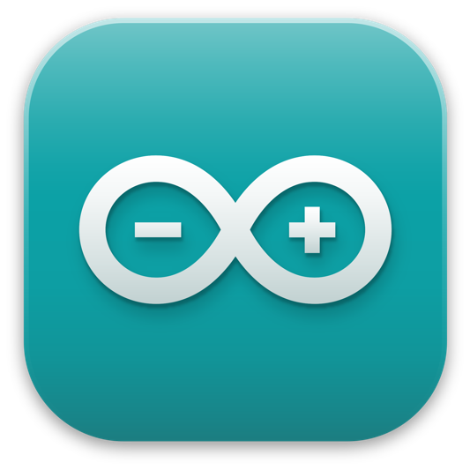

**Key Features**:

* **Open-Source**: Free to use and supported by a large developer community.
* **Simplified Coding**: Uses a beginner-friendly C++-based syntax.
* **Extensive Library Support**: Provides pre-written libraries for peripherals and sensors.
* **Cross-Platform**: Compatible with Windows, macOS, and Linux.
* **Serial Monitor**: Offers debugging and real-time interaction with hardware.
* **Integrated Compilation and Uploading**: Compiles code and uploads it directly to connected boards.

The Arduino IDE is a cornerstone for embedded systems projects, enabling seamless hardware-software integration for DIY and professional applications.

FIREBAse

In the era of rapid prototyping, where innovative ideas demand swift implementation, Firebase emerges as a game-changer for developers. A Google-backed application development platform, Firebase simplifies backend operations, enabling developers to focus on enhancing user experience rather than managing server-side complexities. Its versatility and integration capabilities make it an essential tool for building, scaling, and maintaining modern applications.

**What is Firebase?**

Firebase started as a YC11 startup and has grown into a robust app development platform powered by Google Cloud. It offers a suite of tools and services that cater to Android, iOS, and web app development, providing solutions for data storage, user authentication, analytics, hosting, and more. At its core, Firebase operates as a Backend-as-a-Service (BaaS), allowing developers to bypass traditional server-side coding by utilizing ready-made APIs and services.

One of the standout features of Firebase is its ability to manage real-time data. Using its **Realtime Database**, a NoSQL JSON-based database, developers can store and synchronize data across multiple devices in real time. Firebase also offers **Cloud Firestore**, a flexible and scalable NoSQL database that supports more complex queries and better scalability, making it ideal for modern app development.



**Key Features of Firebase**

1. **Realtime Database**: Firebase's Realtime Database is designed for real-time and multi-user environments. It allows data synchronization across all connected devices, making it perfect for apps like live streaming and chat messaging.
2. **Cloud Firestore**: This advanced NoSQL database provides developers with scalable storage and flexible querying capabilities. It supports offline data access, enabling apps to function seamlessly even without an internet connection.
3. **Authentication**: Firebase simplifies user authentication by offering multiple sign-in methods, including email/password, OAuth providers (e.g., Google, Facebook), and anonymous accounts. This service ensures secure user management with minimal setup.
4. **Cloud Functions**: With Cloud Functions, developers can execute backend logic without the need to manage servers. These functions are triggered in response to events, allowing for custom workflows tailored to application requirements.
5. **Cloud Messaging**: Firebase Cloud Messaging (FCM) facilitates the delivery of push notifications to user devices, enhancing engagement and communication.
6. **Hosting**: Firebase provides fast, secure, and scalable hosting for web applications. It supports static and dynamic content with built-in SSL for enhanced security.
7. **Analytics**: Firebase Analytics delivers detailed insights into user behavior and app performance. Developers can track user interactions and measure key metrics to improve their applications.
8. **Integration**: Firebase integrates seamlessly with Google Cloud services, Google Ads, BigQuery, and third-party tools like Slack. This integration enhances app management and operational efficiency.

**Why Use Firebase?**

Firebase eliminates the traditional complexities of backend development, making it a go-to platform for both startups and established enterprises. Its real-time synchronization capabilities are invaluable for interactive apps, while its comprehensive suite of tools enables efficient app management. From simplifying database interactions to providing scalable solutions, Firebase empowers developers to focus on innovation.

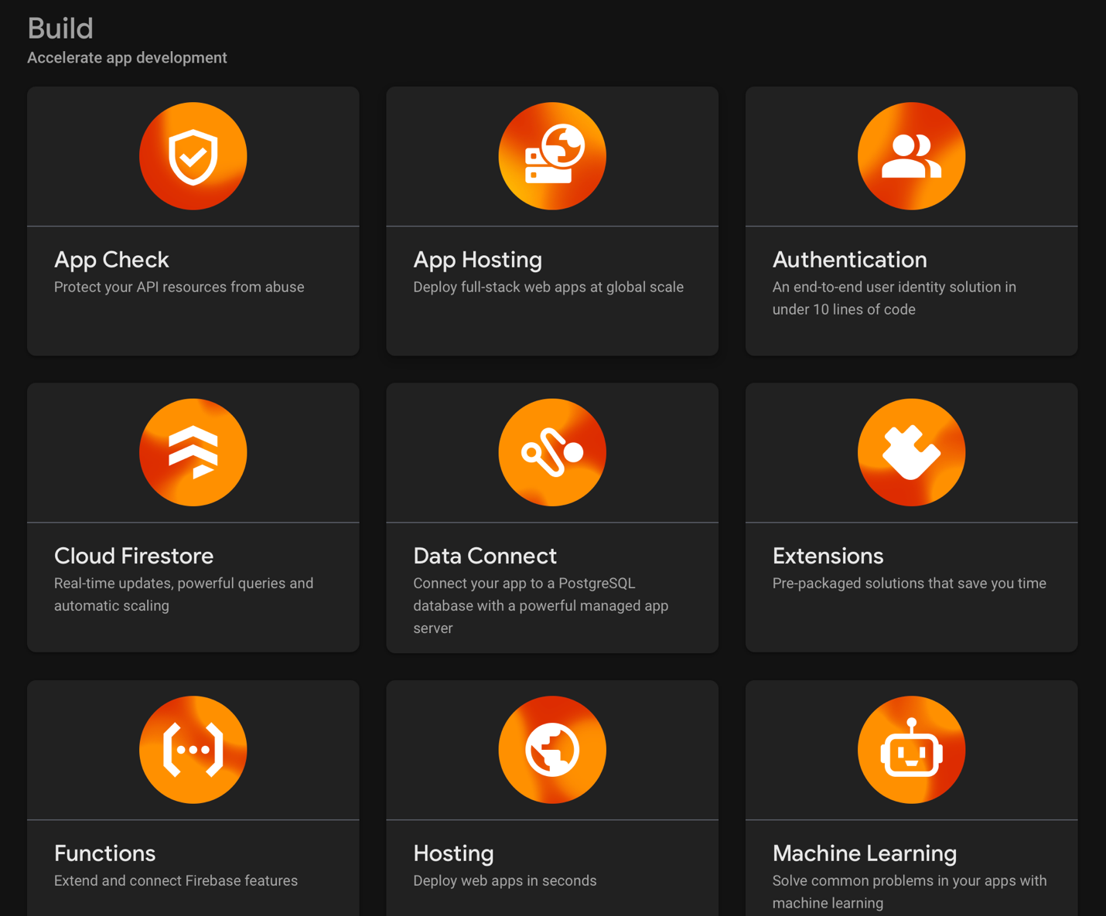

Additionally, Firebase supports secure deployment and offers a user-friendly control dashboard. With tools for crash reporting, performance monitoring, and A/B testing, it ensures that developers have everything they need to deliver a seamless user experience.

ReactJS

**Introduction to React.js**

React.js, commonly referred to as React, is a widely used open-source JavaScript library developed by Facebook. It is designed to build dynamic and interactive user interfaces for web applications. First introduced in 2013, React has gained immense popularity among developers due to its simplicity, flexibility, and high performance. Unlike traditional web development methods that rely on manipulating the Document Object Model (DOM) directly, React employs a virtual DOM that optimizes and accelerates the rendering process.

React enables developers to create applications by breaking down complex user interfaces into smaller, reusable components, making it easier to manage and maintain large-scale projects. The library's component-based architecture, combined with its efficient update mechanism, allows for smooth and real-time user experiences. React is particularly well-suited for building single-page applications (SPAs) where dynamic content needs to be rendered and updated frequently without reloading the entire page.



React’s widespread adoption can be attributed to its ease of use, developer-friendly tools, and the extensive ecosystem of libraries and frameworks that complement it. These features make React a top choice for both small projects and enterprise-level applications, empowering developers to build fast, scalable, and maintainable web applications.

**Key Features of React.js**

1. **Component-Based Architecture**  
   React uses a component-based approach to build user interfaces. A component is a self-contained unit that encapsulates its own logic, state, and rendering process. Components can be reused throughout an application, making the codebase more modular and maintainable. By breaking down the UI into smaller, reusable components, developers can manage complex applications with ease.
2. **Virtual DOM for Enhanced Performance**  
   One of the standout features of React is its Virtual DOM, which is an in-memory representation of the real DOM. When a component’s state changes, React first updates the Virtual DOM and compares it with the previous version. Then, it updates only the changed parts of the real DOM, leading to faster rendering and improved performance. This selective re-rendering process makes React applications more efficient, especially in cases where the UI updates frequently.
3. **Unidirectional Data Flow**  
   React follows a unidirectional data flow, meaning data flows from parent components to child components. This predictable flow makes the application state easier to manage and debug. When the state of a component changes, React efficiently updates the affected parts of the UI, ensuring that the user interface remains consistent and in sync with the application’s state.
4. **Declarative Syntax**  
   React allows developers to describe how the user interface should look based on the application’s state, rather than manually updating the DOM. This declarative syntax makes the code more intuitive, easier to debug, and simpler to maintain. React will handle the updates to the DOM automatically when the state changes, making it less error-prone compared to imperative programming.

**Why React.js is Preferred Over Other Frameworks**



Several factors contribute to React’s widespread adoption over other JavaScript frameworks and libraries, such as Angular and Vue.js:

1. **Component-Based Architecture**: React’s component-based architecture allows developers to create modular, reusable components that are easier to test, debug, and maintain. This modularity helps in large-scale application development, making it possible to manage and scale projects more effectively.
2. **Virtual DOM for Optimized Performance**: The Virtual DOM is a significant advantage React has over other frameworks. Whenever data changes, React updates the Virtual DOM first, compares it with the real DOM, and only updates the actual UI where necessary. This process improves performance by reducing unnecessary updates and rendering operations.
3. **Unidirectional Data Flow**: React enforces a one-way data flow, meaning that data is passed from parent to child components in a predictable manner. This makes applications easier to debug and maintain because the state changes are tracked and can be traced back to their origin.
4. **Strong Ecosystem and Community Support**: React has a large and active community that contributes to its development and provides an array of third-party libraries and tools. With tools like React Router for routing and Redux for state management, developers can easily extend React's functionality. Additionally, the official support from Facebook ensures continuous development and improvement of the library.
5. **React Native for Mobile Development**: React Native is a framework that enables developers to use the same codebase for building native mobile applications for both iOS and Android. By leveraging React Native, developers can create cross-platform mobile apps without needing to learn a completely different technology for each platform.

